Modified Green Fluorescence Protein (GFP) 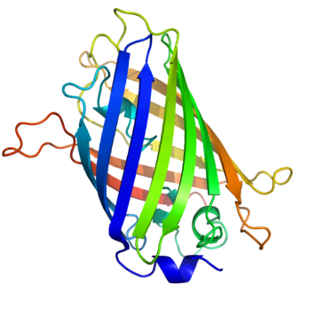

Supervisor: Eva Petersen, Leonid Gurevich
The green fluorescent protein (GFP) is a protein, comprised of 238 amino acids (26.9 kDa), originally isolated from the jellyfish Aequorea victoria that fluoresces green when exposed to blue light. The GFP from A. victoria has a major excitation peak at a wavelength of 395 nm and a minor one at 475 nm. Its emission peak is at 509 nm which is in the lower green portion of the visible spectrum.
In cell and molecular biology, the GFP gene is frequently used as a reporter of expression. In modified forms it has been used to make biosensors, and many animals have been created that express GFP as a proof-of-concept that a gene can be expressed throughout a given organism. To date, many bacteria, yeast and other fungal cells, plant, fly, and mammalian cells have been created using GFP as a marker.
Due to the potential for widespread usage and the evolving needs of researchers, many different mutants of GFP have been engineered. The first major improvement was a single point mutation (S65T) reported in 1995 in Nature by Roger Tsien. This mutation dramatically improved the spectral characteristics of GFP, resulting in increased fluorescence, photostablility and a shift of the major excitation peak to 488nm with the peak emission kept at 509 nm. Many other mutations have been made, including color mutants; in particular blue fluorescent protein (EBFP, EBFP2, Azurite, mKalama1), cyan fluorescent protein (ECFP, Cerulean, CyPet) and yellow fluorescent protein derivatives (YFP, Citrine, Venus, YPet).

In this project we will use genetic methods to create a pool of mutants which will be screened for variations in color and performance. The interesting candidates will be further investigated by fluorescence spectroscopy methods.
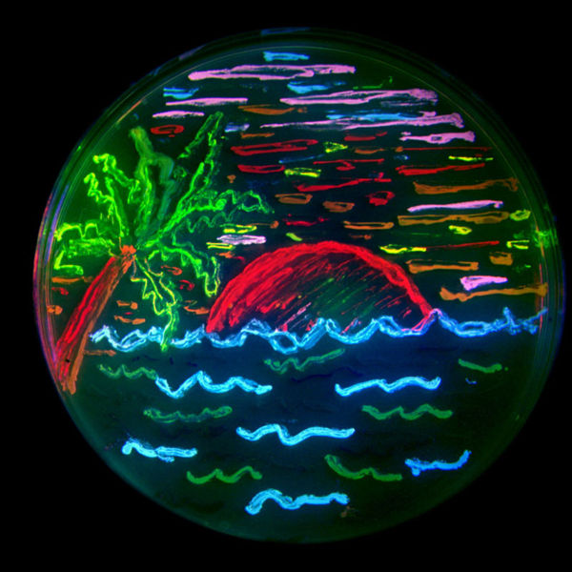
San Diego beach scene drawn with an eight color palette of bacterial colonies expressing fluorescent proteins derived from GFP and the red-fluorescent coral protein dsRed. The colors include BFP, mTFP1, Emerald, Citrine, mOrange, mApple, mCherry and mGrape. Artwork by Nathan Shaner, photography by Paul Steinbach, created in the lab of Roger Tsien in 2006.

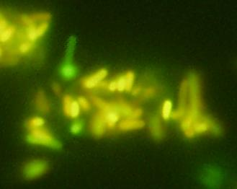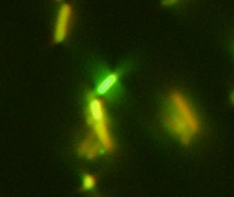
Last year’s project revealed mutants that shifted emission wavelength towards yellow and orange.

